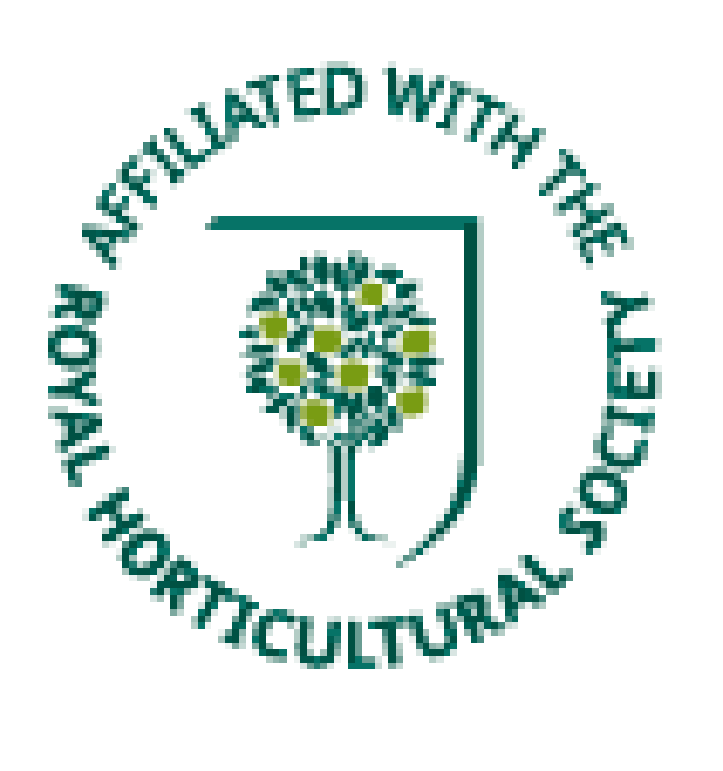

**FDHA Application 2025**

**Subscription**

The Annual subscription is £8 *(New members joining after the 31st August, in any year will receive 18 months membership.)*

To save costs and administration we would prefer that you pay online to;-

**Lloyds Sort Code 30-92-88 A/C 01337228** Fakenham & District Horticultural Association

If you do not use online banking, please pay by cheque payable to ***Fakenham & District******Horticultural Association****.* Please Do Not abbreviate payee name to *FDHA. please send your cheque* to **Tony Churly 58 Salmons way, Fakenham, NR21 8NG**. Please enclose a stamped addressed envelope. Thank you.

To help the Committee provide speakers and events that we hope you will find interesting, please tell us a little about your **style of gardening**.

Do you have an **allotment**, **large** or **small** **garden** or somewhere smaller? Do you consider yourself a **novice**, **have some knowledg**e, **experience** or are a **specialist** gardener? (*Please strike out those descriptions that do not apply.)***Name** Mr/Mrs/Miss………………………………………………………………………………

Address……………………………………………………………………………………

.................................................................................................................................

…………………………………………………………………………………………….

Postcode…………………… Phone or mobile :..................................................

E-mail address……………………………………………………………………………

DATA PROTECTION

The Membership Secretary is the data processor and the data protection officer. Together with the Secretary they will be the only Committee members to have access to your details. We will always treat your personal information with great care. The purpose for processing the information is for your membership of FDHA record and to contact you about Association activities. Your information will not be shared with third parties.

Signature: …………………………………………………… Date: / /

*For Office use only*

*Members No.*